Here are the order numbers (on left) and oLPN numbers (on right)

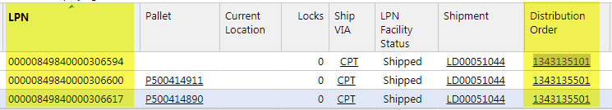

**Jeremy Mendoza**

**Associate DC Production Scheduler**

**760-603-5177**

